The Hon. Gladys Berejiklian MP
Premier of New South Wales
Correspondence via email:

September 15, 2020

Dear Premier,

We are writing to you regarding any financial incentives your state is providing or is considering providing to Qantas for the airline to carry out work, develop operations or move offices, including its headquarters.

As you will be aware Qantas has already received $800 million from the Federal Government in taxpayers’ subsidies, from the Jobkeeper Programme, designed to maintain the connection between workers and employers, and other aviation financial support. Despite this Qantas management announced three weeks ago it was outsourcing workers across its entire ground operations.

This move means Qantas management aims to never directly employ another baggage handler, ramp worker or cabin cleaner. Instead it will contract out the work to operators which pay workers less. This includes Swissport, which has been exposed over safety and security breaches and which the Fair Work Commission confirmed in a case last year has been paying its workers below the award since 2012.

The Federal Government failed to set conditions for the public money which has already gone to Qantas. Now taxpayers will pay the double burden of providing financial supports to the airline while at the same time as seeing aviation Qantas jobs axed and outsourced. Recent media report show Qantas planned 10 years ago to kill off its ground operations, highlighting how the outsourcing is not linked to the pandemic.

We do not want to see NSW make the same mistake as the Federal Government has. We ask you to consider the many hundreds of Qantas, QGS and Jetstar workers. Some have decades of skills and experience which will be lost if the outsourcing proceeds. We ask you to also consider the NSW travelling public who will be forced to experience lower standards in service and safety should the Qantas work be outsourced to the likes of Swissport.

We are therefore asking you to ensure that any public financial incentives provided by your state to Qantas carries the following conditions:

- That Qantas ensures fair labour standards throughout its supply chain, including any contracted workers in its supply chain. These standards must ensure that workers in the Qantas supply chain are paid the same rate for doing the same job.

- That Qantas commits to retaining its workers to carry out the jobs it needs done and agrees to shelve plans to outsource workers, including those in its ground operations.

We stand ready to discuss this with you further and will happily facilitate a meeting with
NSW airport workers from the Qantas group whose livelihoods are under threat.

We look forward to hearing from you soon.

Yours sincerely
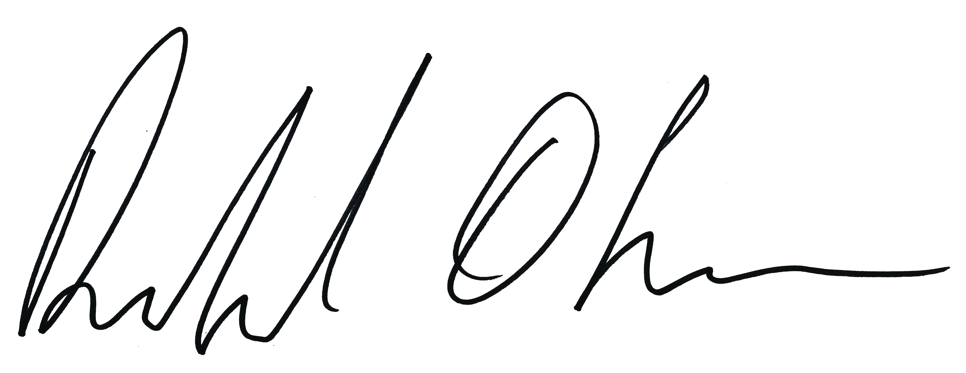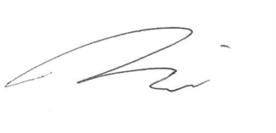

Richard Olsen Michael Kaine
NSW Branch Secretary National Secretary

